Nutrition App Using Gemini Pro: Your Comprehensive Guide To Healthy Eating And Well-Being Final Report

**Team ID: SWTID1720437635**

Team leader: Jerlshin J G

Team member: Vittal J S

**1. Introduction:**

**1.1 Project Overview:**

Nutritionist AI is a groundbreaking mobile application designed to offer personalized dietary recommendations and nutritional advice using the advanced Gemini Pro model. The app leverages artificial intelligence to analyze user data, dietary preferences, and health goals, delivering customized meal plans, nutritional insights, and wellness tips. The primary goal of Nutritionist AI is to foster healthier eating habits and enhance overall well-being through intelligent, data-driven recommendations.

**1.2 Objectives:**

The main objective of this project is to develop and launch Nutritionist AI, a mobile application that utilizes machine learning to:

* Analyze user data, health goals, and dietary preferences.
* Generate personalized meal plans, nutritional insights, and wellness tips.
* Promote healthy eating habits and empower users to take control of their well-being.

**2. Project Initialization and Planning Phase:**

**2.1 Define Problem Statement:**

Many individuals struggle with maintaining healthy eating habits due to factors such as lack of knowledge, conflicting information, and difficulty in creating personalized meal plans. This can lead to unhealthy dietary choices, nutritional deficiencies, and challenges in reaching weight management or fitness goals.

**2.2 Project Proposal (Proposed Solution):**

Nutritionist AI will address these challenges by using machine learning to personalize the user experience. The app will collect user data, such as dietary restrictions, allergies, activity levels, and health goals. This data will be analyzed by the Gemini Pro model to generate:

* Personalized Meal Plans: Tailored meal plans that meet individual needs and preferences.
* Nutritional Insights: Detailed breakdowns of nutrient content in meals, highlighting potential deficiencies or areas for improvement.
* Wellness Tips: Guidance on healthy eating habits, food preparation techniques, and strategies for achieving lifestyle goals.

**2.3 Initial Project Planning:**

The initial conception of Nutritionist AI arose from the need for a comprehensive health guide app for overall health and nutrition. The initial project planning involved work being divided among team leaders and members as follows:

* Requirement Specification: Naman Chadha, Sarath Chander
* Initialization of Google API Key: Naman Chadha, Sarath Chander
* Interfacing with Pre-Trained Model: Pritam Satpathy, Ana Singh
* Model Deployment: Pritam Satpathy, Ana Singh

**3. Data Collection Phase:**

**3.1 Data Collection Plan and Raw Data Sources Identified:**

Using a web framework like Streamlit, the app will create a user interface with dropdowns, sliders, text input fields, and potentially an image upload option, allowing users to provide their preferences or queries. The core functionality comes from the google.generativeai library, which provides methods to send the processed (or raw) user input to the Generative AI model and receive the generated response from the model.

**3.2 Data Quality Report:**

Since we are using the Gemini-pro-vision model, the trained data in the Gemini Pro Vision model will be utilized.

**3.3 Data Preprocessing:**

The user-input data will be further processed during the data preprocessing phase.

**4. Model Development Phase:**

**4.1 Model Selection Report:**

* Gemini Pro: A powerful AI tool that can understand and work with various data types like text, images, and even code, enabling it to analyze and create content in new and innovative ways.
* Gemini Pro Vision: Capable of analyzing text and generating new content, with the added ability to understand images and videos. This allows it to answer questions based on visual content, describe visual elements, and even create captions.

**4.2 Initial Model Training Code and Model Validation and Evaluation Report:**

The initial model training code will be showcased in the future through a screenshot. The model validation and evaluation report will include classification reports, accuracy, and confusion matrices for multiple models, presented through respective screenshots.

### CODE:

import streamlit as st  
from PIL import Image  
import google.generativeai as genai  
import os  
from dotenv import load_dotenv  
  
# Load environment variables  
load_dotenv()  
  
# Configure Google Generative AI  
genai.configure(api_key=os.environ["GOOGLE_API_KEY"])  
  
model = genai.GenerativeModel(model_name="gemini-1.5-flash")  
  
# Sidebar for navigation and inputs  
st.sidebar.title("Navigation")  
st.sidebar.write("Use the sidebar to navigate through the app.")  
st.sidebar.image("https://clipground.com/images/logos-png-8.png", width=200)  
  
  
st.sidebar.subheader("Upload an Image")  
uploaded_image = st.sidebar.file_uploader("Choose an image...", type=["jpg", "jpeg", "png"])  
  
st.sidebar.subheader("Select a Scenario or Write Your Own Query")  
scenarios = {  
 "Scenario 1: Weight Loss Journey": """  
 A user with a goal to lose weight uses Nutritionist AI to aid in their weight loss journey.   
 With specific dietary preferences and a certain activity level, they input their dietary preferences and health goals into the app.   
 Nutritionist AI creates a calorie-controlled, nutrient-dense meal plan tailored to their diet.   
 The user logs their meals by taking photos or scanning barcodes, and the app provides feedback on their calorie intake   
 and nutritional balance, suggesting necessary adjustments. By syncing their fitness tracker, the app integrates their   
 physical activity data, offering comprehensive insights to help the user stay on track with their weight loss while   
 maintaining proper nutrition.  
 """,  
 "Scenario 2: Managing Diabetes": """  
 A user with Type 2 Diabetes relies on Nutritionist AI to manage their condition through diet.   
 They input their dietary preferences and diabetes condition, and the app generates meal plans that focus   
 on low carbohydrate and high fiber content to help control their blood sugar levels. The user uses the app to log their meals,   
 receiving immediate feedback on their suitability for diabetes management. Detailed nutritional breakdowns   
 highlight carbohydrate content and glycemic index, aiding the user in making informed food choices. Additionally,   
 the app provides educational resources about managing diabetes through diet, keeping the user well-informed and empowered   
 to handle their condition better.  
 """,  
 "Scenario 3: Building Muscle": """  
 A user who is a strength training enthusiast uses Nutritionist AI to support their goal of gaining muscle mass.   
 With a preference for high-protein meals and an intense workout regime, they input their dietary preferences and fitness   
 goals into the app. Nutritionist AI generates meal plans rich in protein and essential nutrients necessary for muscle growth.   
 The user benefits from a variety of high-protein recipes that cater to their needs, with each recipe including detailed   
 instructions and nutritional information. By connecting their fitness tracker, the app accounts for their caloric expenditure   
 and provides insights on balancing their protein intake with their workouts, optimizing their muscle-building efforts.  
 """  
}  
  
scenario_options = list(scenarios.keys()) + ["Write your own query"]  
scenario_choice = st.sidebar.selectbox("Choose a scenario:", scenario_options)  
  
# Main title and description  
st.title("Nutritionist AI")  
st.markdown("""  
**Nutritionist AI** is an innovative mobile application designed to provide personalized dietary recommendations   
and nutritional advice using the advanced capabilities of the **Gemini Pro model**. The app leverages artificial   
intelligence to analyze user data, dietary preferences, and health goals, delivering tailored meal plans,   
nutritional insights, and wellness tips. The primary aim of Nutritionist AI is to promote healthier eating habits   
and improve overall well-being through intelligent and data-driven recommendations.  
""")  
  
if scenario_choice == "Write your own query":  
 prompt = st.text_area("Enter your query here:")  
else:  
 prompt = scenarios[scenario_choice]  
  
# Display uploaded image  
if uploaded_image is not None:  
 img = Image.open(uploaded_image)  
 st.image(img, caption='Uploaded Image', use_column_width=True)  
  
 input_prompt = """  
 You are an expert in nutritionist where you need to see the food items from the image  
 and estimate approximately the total calories, also provide the details of every food items with calories intake   
 is below format  
  
 1. Item 1 no of calories  
 2. Item 2 no of calories  
 ----  
 ----  
  
 and   
 Answer according to the givin in double quotes. Give your point of view based on the Image input and the Prompt.  
  
 """  
  
 if st.button("Generate Nutrition Advice"):  
 with st.spinner('Generating response...'):  
 response = model.generate_content([input_prompt, img, prompt])  
 st.write("### Nutrition Advice:")  
 st.write(response.text)  
else:  
 st.info("Please upload an image to proceed.")

**5. Deployment Phase:**

**5.1 Deployment Strategy:**

* Infrastructure Setup: A Generative AI model, a server or cloud instance with sufficient processing power (CPU, GPU) and memory to handle model inference (text generation) requests.
* Storage: To store project code, model weights (if not using a pre-trained model as a service), and any generated text logs. Cloud storage options are ideal for scalability and accessibility.
* Integration: API development, front-end integration, user input handling, and output presentation.
* Model Performance Monitoring: Track key metrics like response time and resource usage. Tools like TensorBoard or cloud monitoring services can be applied.
* Error Handling and Logging: Implement mechanisms to handle potential errors during text generation or user interaction. Log errors for troubleshooting and improvement.

**5.2 User Testing and Feedback:**

* Beta Testing: Evaluate the project in a realistic setting with a wider range of users. Recruit a larger group of users representing the target audience who haven't participated in previous testing phases. Allow users to interact with the project freely and report any issues they encounter.
* Iterative Improvement: Analyze collected data to identify areas for improvement. Prioritize issues based on severity and user impact. Make necessary adjustments to the Generative AI model (e.g., fine-tuning parameters), user interface, or functionalities based on user feedback. Conduct additional rounds of testing if needed to validate the implemented changes.
* Feedback: Collect qualitative data through surveys, interviews, and user recordings (with consent) to understand user pain points, preferences, and suggestions for improvement.

# 6.Results:

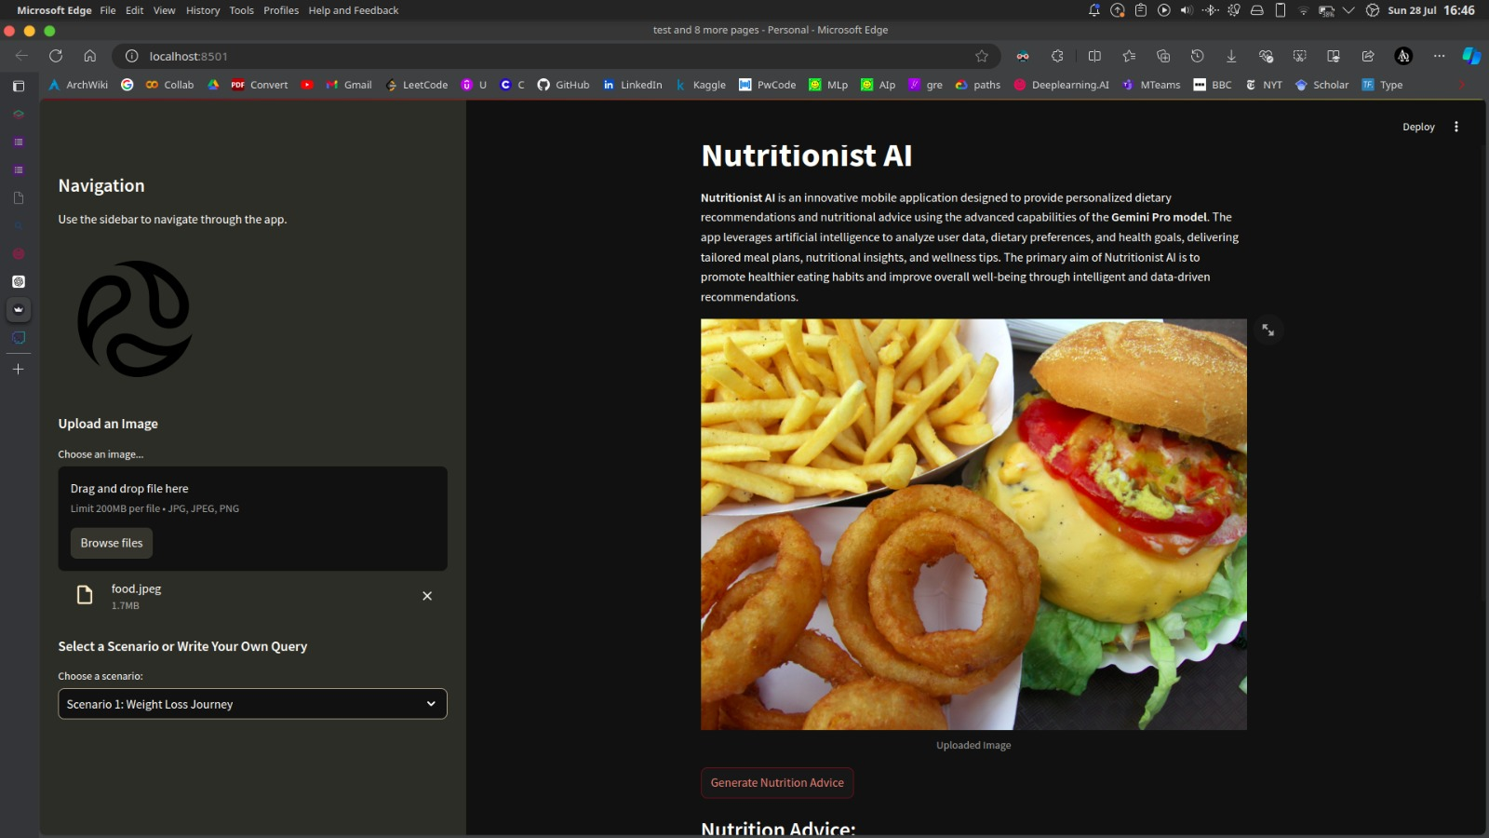

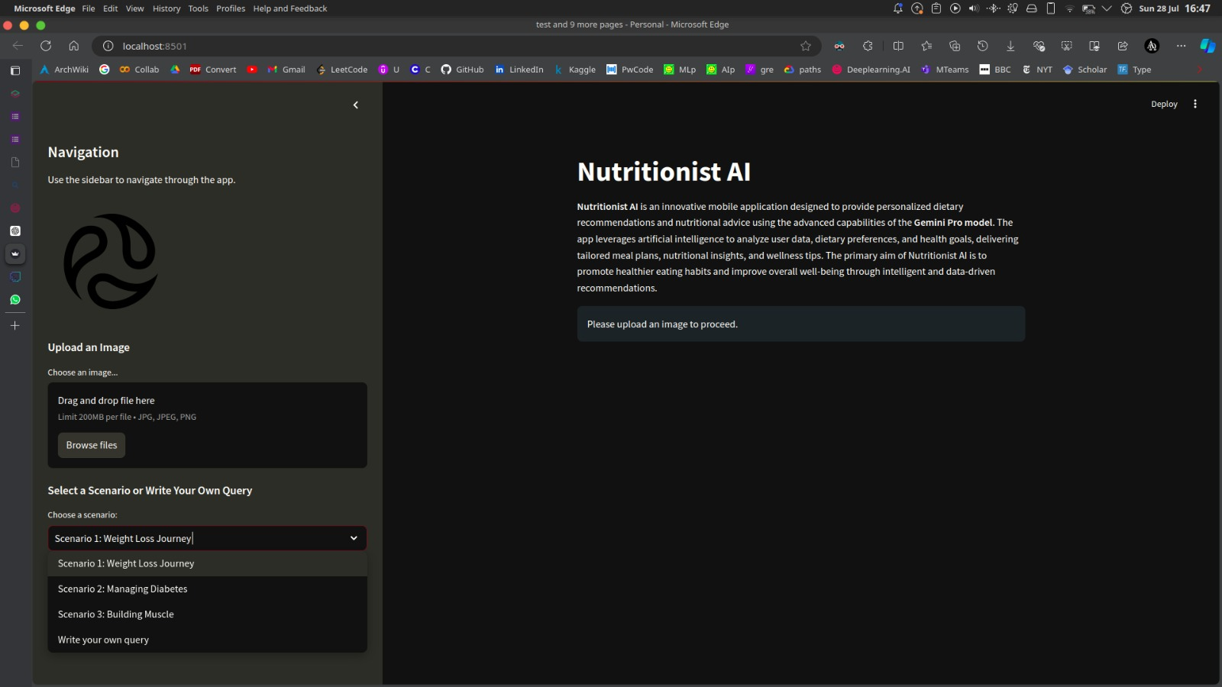

### 7. Advantages & Disadvantages:

### 7.1 Advantages:

### Combines Image Recognition and Text Generation: This project leverages Google's Gemini Pro Vision API for unique functionality, combining image recognition to identify food items in an uploaded image with text generation to analyze the image and provide nutritional information.

### User-Friendly Interface: The Streamlit framework allows for a user-friendly interface with text input for additional information and image upload functionality.

### Potential for Personalized Nutrition Guidance: By incorporating user input through the text prompt, the project could be extended to provide more personalized nutritional information based on dietary restrictions or preferences.

### 7.2 Disadvantages:

### Accuracy Dependence on Image Recognition: The accuracy of the nutritional information hinges on the effectiveness of the image recognition component. Poor image quality or limitations in the image recognition model could lead to inaccurate results.

### Dependence on Accurate Inputs: The accuracy of the recommendations heavily depends on the quality and accuracy of the user-provided data.

### 8. Conclusion:

### Generative AI has the potential to create a user-friendly nutritional analysis tool by combining image recognition with text generation. This project allows users to upload an image of their food and receive information about the total calorie content and individual food items with their estimated calorie intake. The Streamlit interface simplifies user interaction, making it accessible to a broader audience.

### 9. Future Scope:

### Portion Size Estimation: Currently, the project estimates total calories. Integrating image recognition features to estimate portion sizes within the image would lead to more accurate and personalized calorie calculations. Techniques like object detection and image segmentation can be explored to identify and quantify individual food items.

### Allergy and Intolerance Integration: Incorporate functionalities to identify potential allergens or food intolerances based on recognized food items. This would offer valuable information for users with specific dietary needs.

### Progress Tracking and Feedback: Implement features to track user progress over time and provide personalized feedback based on their dietary goals. This could involve graphs or charts to visualize calorie intake and nutrient consumption trends.

### 10. Appendix:

### 10.1 Source Code:

### The source code for the Nutritionist AI project is available in the project’s GitHub repository.

### GitHub & Project Demo Link:

* + - **GitHub Repository:**

https://github.com/Jerlshin/Nutrition-App-using-Gemini-

**Project Demo:**

https://drive.google.com/file/d/1CzynaFZm08SNWzEa9DmLGKPyV7alm54q/view?usp=sharing